**EXPERIMENT 6**

**BLOW FISH ALGORITHM**

AIM: To execute the blow fish algorithm in Python

DESCRIPTION:

**Operations: (Blowfish encrypts 64-bit block with a variable length key)**

1) Sub key Generation:

This process covert the key up to 448 bit long to sub keys totalling 4168 bits.

2) Data Encryption :

This process involves the iteration of a simple function 16 times. Each round contains a key dependent permutation and key and data substitution.

* Blowfish is a very fast algorithm which takes 64 bit input as plaintext and generates 64 bit output cipher text.
* It uses the concept of P-array which use of 21 bit and there are 18 P-arrays P1 to P18.
* Blowfish Algorithm runs 16 times i.e. 16 rounds

***Processes***:

A. Subkey Generation:

* Key Size is variable but blowfish algorithm generates very large sub-keys .The key size is in the range of 32 bits to 448 bits or 14 words.
* Concept of P-array consists of 18, 32 bit sub-keys
* There are 4 S-boxes containing 256 entries of 32 bits
* P-array is initialized first then four s boxes with fixed string
* Then P-arryas are XORed with subkeys ie from P1 to P18 . Once the sub keys are generated the encryption process begins.

B. Data encryption and decryption:

* We use the P arrays and S boxes during this process

**Algorithm for encryption of 64 bit block**

1. Divide X into two blocks CL and XR of equal sizes. Thus both XL and XR will consist of 32 bit each
2. For P=1 to 16

XL = XL XOR Pi

XR = f(XL) XORXR

Swap XL ,XR

Next i

1. Swap XL, XR XOR P18
2. XL = XL XOR P18
3. XR = XR XOR P17
4. Continue XL and XR back into X to get cipher text CT

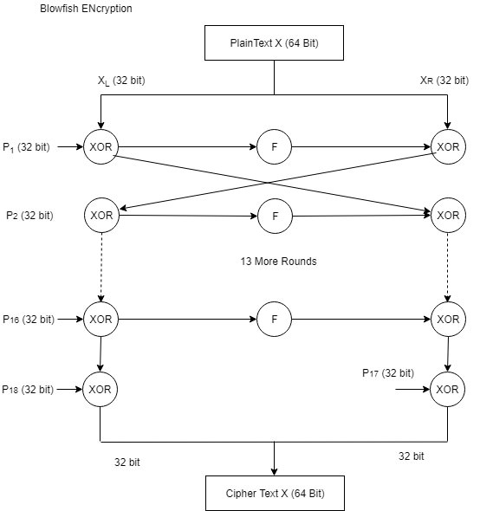

* Function f is as follows

a. Divide the 32 bit XL block into four 8 bit sub blocks named a, b, c, d.

b. Compute f(a,b,c,d) = ((S1, a + S2, b) XOR S3

c) XORSc , d

• Function f in blowfish

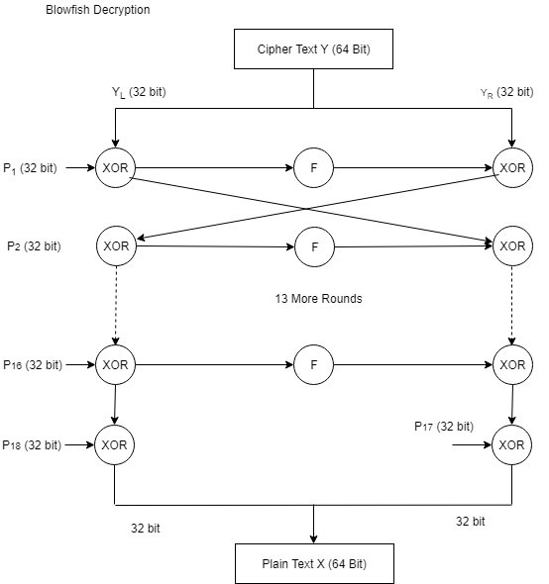

• Blowfish Decryption



|  |  |
| --- | --- |
|  | https://mail.google.com/mail/u/0/images/cleardot.gif  https://mail.google.com/mail/u/0/images/cleardot.gif |
| CODE: |  |
|

import blowfish

cipher=input("Enter key:")

cipher = bytes(cipher, 'utf-8')

cipher = blowfish.Cipher(cipher)

block=input("Enter plain text :")

block = bytes(block, 'utf-8')

ciphertext = cipher.encrypt_block(block)

plaintext = cipher.decrypt_block(ciphertext)

assert block == plaintext

print("Cipher text :",ciphertext)

print("Plain text :",plaintext)

OUTPUT:

